**Lab 1: Setting Up IAM Users**

Paul Polsinelli

Information Technology, Arizona State University

IFT 472: Managing the Cloud

Professor Neff

Aug 30th, 2020

**Lab 1: Setting Up IAM Users**

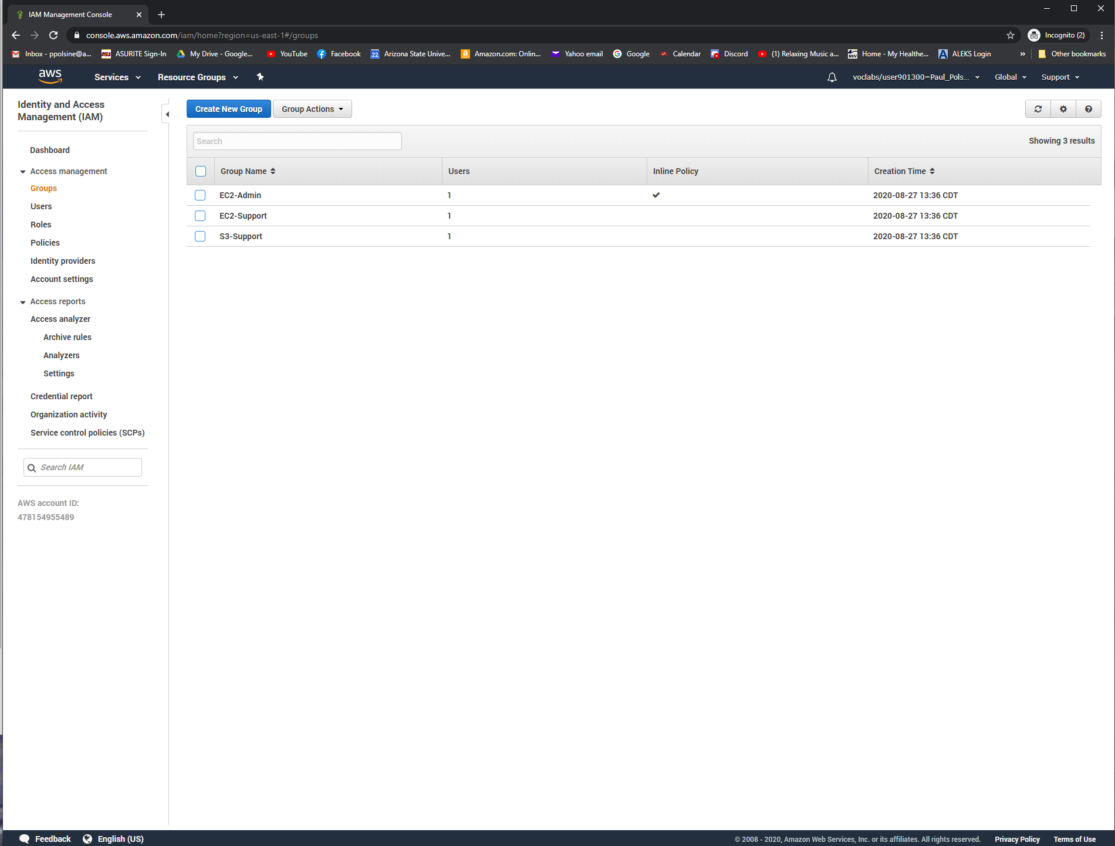

*Figure 1*. Screenshot showing the three groups with 1 user in each group.

**Lab 1: Setting Up IAM Users**

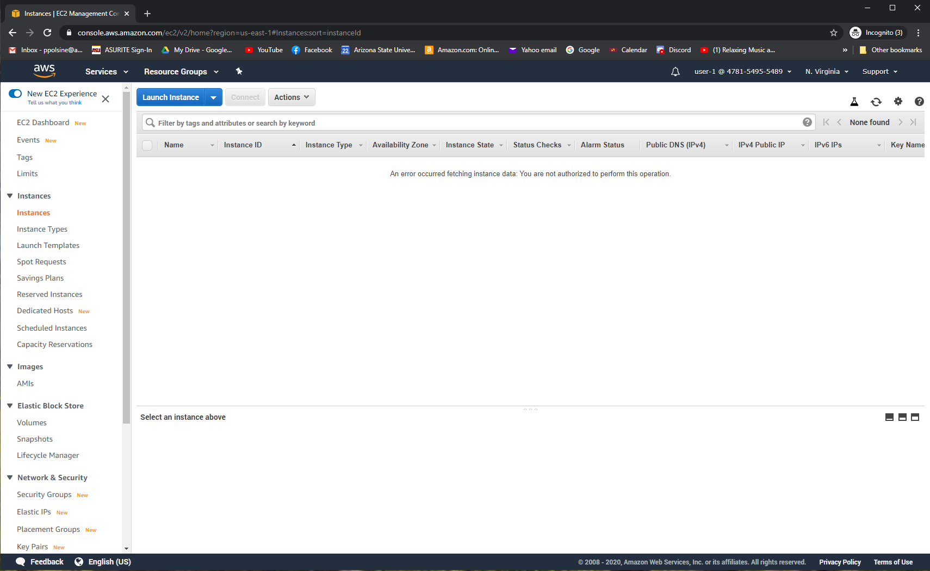

*Figure 2.* Screenshot showing inability to access Instances.

**Lab 1: Setting Up IAM Users**

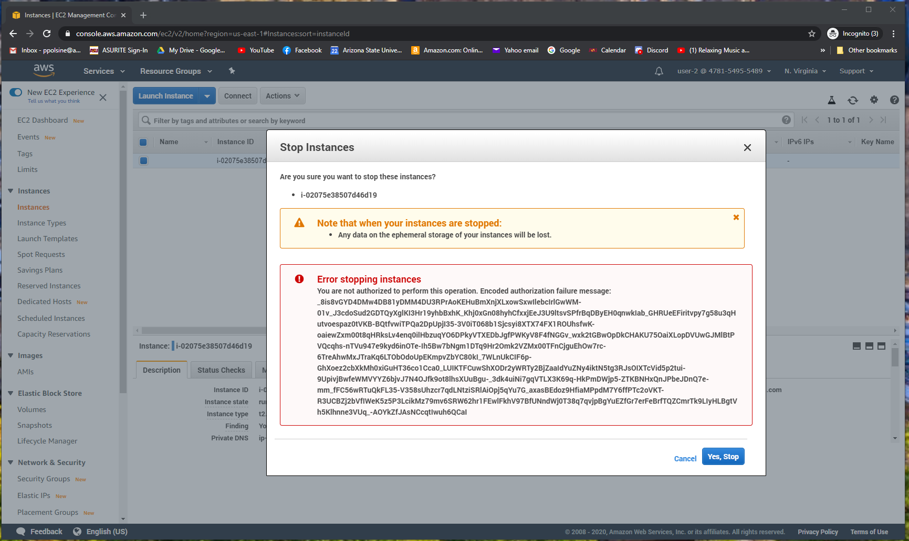

*Figure 3.* Screenshot showing the error trying to stop an instance.

**Lab 1: Setting Up IAM Users**

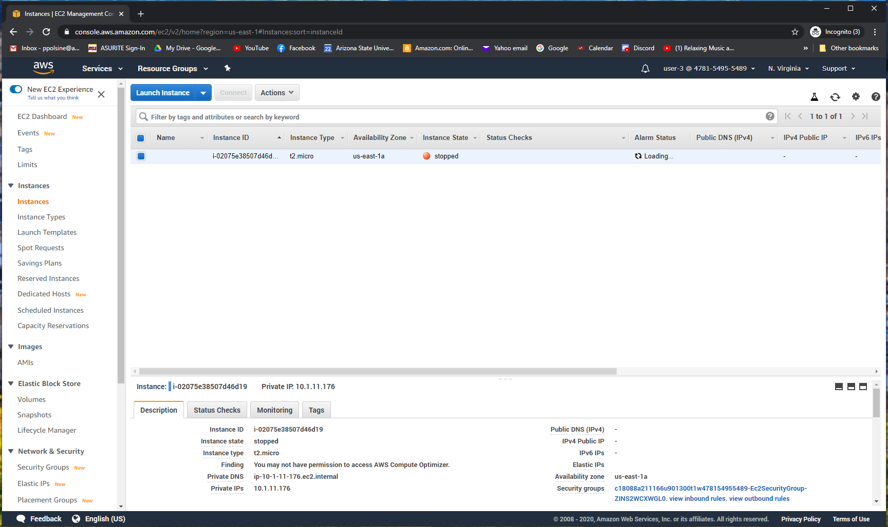

*Figure 4.* Screenshot showing a stopping or stopped EC2 instance.